**技能的时间线**<http://bbs.rohome.net/thread-1146930-1-1.html>

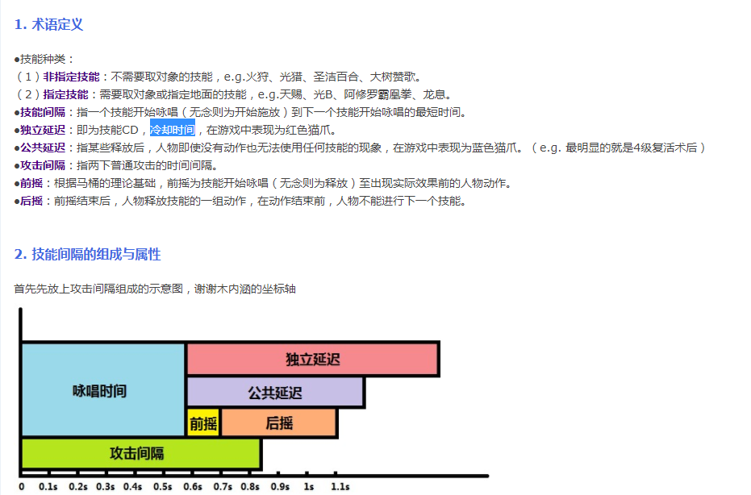

**技能系统实现分析**<http://www.gad.qq.com/article/detail/23886> <http://www.gad.qq.com/article/detail/23887>

<http://www.cnblogs.com/badkeeper/articles/1624065.html>

<http://blog.csdn.net/jinsenianhua2012/article/details/50581213>

<http://blog.csdn.net/ozhonglou1234/article/details/50519314>

<http://blog.csdn.net/alistair_chow/article/details/53319888>

dota2技能说明<http://moddota.com/forums/discussion/14/datadriven-ability-breakdown-documentation>

说明技能的概念<http://bbs.rohome.net/thread-1146930-1-1.html>

对dota技能的说明<https://developer.valvesoftware.com/wiki/Dota_2_Workshop_Tools:zh-cn/Scripting:zh-cn/Abilities_Data_Driven:zh-cn>